|  |
| --- |
| AIM Duration: 3 hours |
| * Create an invitation letter using mail merge for n invitees |

|  |
| --- |
| LEARNING OUTCOME |
| Able to create document spread sheet and make presentation using open office. |

|  |
| --- |
| REQUIREMENT |

|  |
| --- |
| List of Hardware/Software requirements:   * Computer Desktop/Laptop * Windows Operating system * Open Office |

PROCESDURE

Step 1: Create your email the way you want it with the roll-your-own approach.

Step 2: Save it. But keep it open.

Step 3: In Writer set up email configuration. Choose Tools > Options > OpenOffice.org Writer > Email. Key settings are the outgoing server name and the port number. You just need to do this once. If you have security on your email, like requiring a password to send, you will have to click the Server Authentication button and enter additional information.

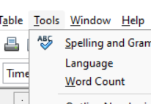

Step 4: Choose Tools > Mail Merge Wizard and check Use the Current Document. Or else browse to your document, and click Next.

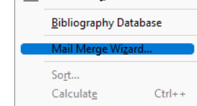

Step 5: Choose E-mail message and click Next.

Step 6: Select the database you are using and the table. Click OK and click Next.

Step 7: Keep clicking Next until you are here. Fill it in by selecting the field from the database that has the emails in it, and anything else you want. Click Send Documents.

